tHE

ENLIGHTENER

bRANCH 99 Belleville

Important dates
Feb 11 – Freddy Vette and his rinestone plowboys - $20.00 per person
Feb 12 – General meeting at 7p.m.
Branch will be closed on
Monday Feb. 19 –family day

Branch Hours

Monday – Wednesday– 11:30 am to 11 pm
Thursday – 1 pm to 11 pm
Friday – 11:00 am to 1 am
Saturday – Noon to 6 pm
Sunday – Special Events Only

Presidents Message

The Enlightener

The Enlightener is published 10 times per year with the express permission of RCL Branch 99 Executive.

Individuals who would like to submit articles and photos for the Newsletter are to submit them to the following e-mail address:
swelch2@cogeco.ca

Please note, the editor reserves the right to edit any submission to fit with the newsletter’s formatting & content rules.

Advertising space is available for businesses interested in supporting the Legion. Please contact the editor at the e-mail address provided above.

On-line copies of the Enlightener are available at our website: mylegion.ca/web/. Just click on the Enlightener tab and scroll down to the issue you wish to view.

Editor: Shirley Stewart

Wi-Fi

RCL Branch 99 now has Wi-Fi in the Club Room. Please see the Bar Staff for the password.

Ralph Collins

Comrades, we are now just three months away from election. This is important because many have not attended meetings in the last year and the regulations states that in order to stand for election you must attend three meetings in a twelve month period. You must also be a member in good standing of the Branch for one year prior to elections.
Now I point this out because we need members who can and will stand for election. There are a number of positions to be filled and jobs needing to be done. Your active support and participation is needed in order to continue any prosperity for your Legion. For this reason I urge you to give serious consideration to participation in the coming election. If I might paraphrase J.F. Kennedy….

ASK NOT WHAT YOUR LEGIO CAN DO FOR YOU.

BUT RATHER ASK WHAT YOU CAN DO FOR YOUR LEGION

We joined the Legion for the purpose of being a help to our veterans, our community and our members to come to the aid of your branch.

Let me remind you once again there is only three General Meetings before Election Day. If you have not attended three meeting please attend these last three.

Entertainment
Ralph Collins

Feb. 11 (Sunday) 2p.m till 6 p.m. Freddy Vette and his Rhinestone Plowboys. $20.00 per person.

I would like to say a big thankyou to the members and guests who brought in food from our last couple of dances that we had asked for food for Gleaner’s Food Bank.

On Dec. 3 we donated $184.00 and 150 pounds of food
On January 21 we donated $155.00 and 218 pounds of food.

Shirley

Membership
Mary Presley

The membership office has a new telephone number 613-779-1343. There is an answering machine and I will get back to you as soon as possible with answers to your questions.

Also, if you have an email address wold you please send an email to membershipbranch99rcl@gmail.com
So your email can be added to our distribution list.

There is no “I” in Team but there is a “u” in volunteer!
And
There is no “I” in Team, but we sure are glad there is a “u” in our volunteers!
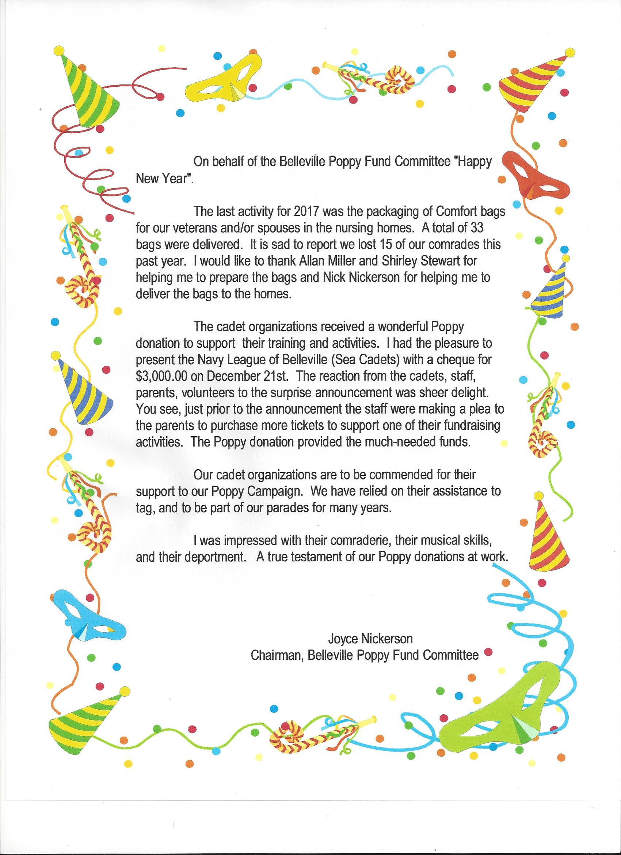Sports
Dave Finley

Dart Teams going to District

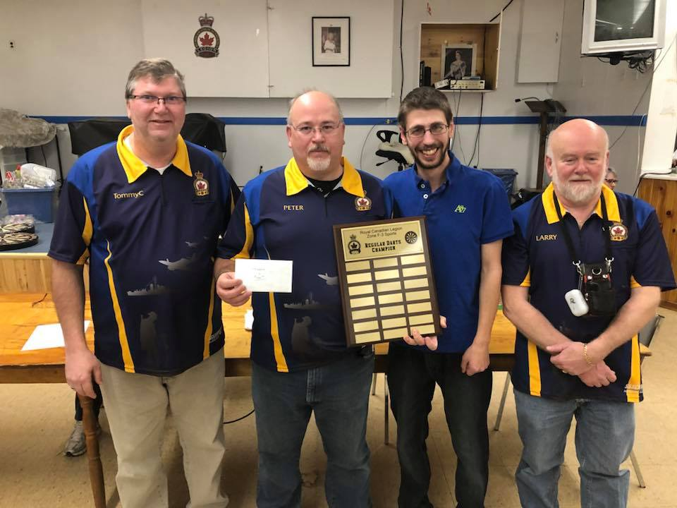
PeterMcCarthy, Cory McCarthy, Tom Cross Jr. and Larry Ford

Senior Darts going to District -Willie Sauliner, Tom Coolen Jr. Steve Bell and Jake Cole

Doubles - Tim Prewer and Brad Evans

Singles - Peter McCarthy, Tim Prewer, Terry Collins

Shuffle Board Teams going to District

1st place – Piction
2nd Place – Deserento
3rd Place Belleville – Butch Doolittle and Bill Clapp
4th place Belleville – Dave Finley and Bob Boyle

Good Luck to all participates

Dart Teams going to Provincials

1st place – Havelock
2nd place (not sure)
3rd place – Belleville ( Terry Collins, Steve Bell, Tom Coolen Jr. and Willie Sauliner )

Doubles

Terry Collins and Steve Bell
Tim Prewer and Brad Evans

Youth Education
Allan Miller

Come and hear the 99 Royal Canadian Legion Youth Speeches February 24

Kitchen

Monday – Wednesday 11:30 till 2:30
Thursday – closed
Friday – 11:30 till 7

Specials available daily

Sick and Visiting

John Norton in BGH
John Wilson recovering at home
Doug and Lorna Goderich – sent a card on the passing of Doug’s Brother
Steve Smith –sent a card on the passing of his wife Arlene
Marion Brown – recovering at home
Don McPherson – recovering at home
Harriet Nickerson – recovering at Bayview Retirement home
Harold Thompson – at the Marmora Seniors Home

Congratulations to all the Trillium 2000 club for their hard work on the Kettle Campaign.

In the photo below are Legion Members.
Brenda Potts, Joe Drummond, Doug and Lorna Goodrich, Lily Young, Heather and Gord. Hope I did not forget anyone.
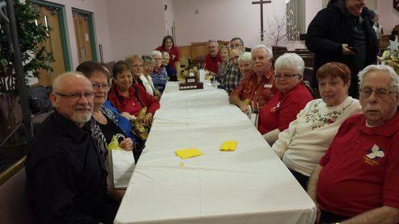
“RETARDED” GRANDPARENTS
Written by a third grader, on what his grandparents do.

After Christmas, a teacher asked her young pupils how they spent their holidays away from school. One child wrote the following:

We always used to spend the holidays with Grandma and Grandpa. They used to live in a big brick house, but Grandpa got retarded and they moved to Arizona. Now they live in a tin box that has wheels, but its strapped to the ground. They ride around on their bicycles, and wear name tags, because they don’t know who they are anymore.
They go to a building called a wreck center, but they must have got it fixed because it is all okay now, they do exercises there, but they don’t do them very well. There is a swimming pool too, but they all just jump up and down in it with hats on. At their gate, there is a doll house with a little old man sitting in it he watches all day so nobody can escape.
Sometimes they sneak out, and go cruising in their golf carts, Nobody there cooks, they just eat out. And, they eat the same thing every night – early birds. Some of the people can’t get out past the man in the doll house. The ones who do get out, bring food back to the wrecked center for pot luck.
My Grandma says that Grandpa worked all his life to earn his retardment and, says I should work hard so I can be retarded someday too. When I earn my retardment, I want to be the man in the doll house. Then I will let people out, so they can visit their grandchildren.
PRICELESS
Legion Office – 613 962-2643, Fax 613 968-9971, Bar 613 968-9053
www.mylegion.ca/web/
E-mail: info@mylegion.ca/web/
132 Pinnacle Street, Belleville Ontario, K8N 3A4

Membership Office Phone - 613-779-1434

President Ralph Collin 613- 962-8754
Past President Andy Anderson 613- 968-7261
1st Vice President Joyce Nickerson 613-966-7179
2nd Vice President Jack Crozier 613 962-2101 613 920-2101
3rd Vice President Mike Joyce 613 967-5923
Secretary Heather Fehr
Treasurer Joe Drummond 613- 962-7947
Padre/Funerals Ralph Collins 613- 962-8754
Sgt-At-Arms Don MacPherson 613- 779-0773 613 847-1415
Membership Mary Presley 613- 967-6494
Honors & Awards Robert Kooman 613-969-7706
Service Officer Doreen Guimont 613 966-4297
Poppy Joyce Nickerson 613-966-7179
Sports/Track & Field Dave Findlay 613-968-4080
Youth Education Allan Miller 613- 968-9655
Bingo Frank Freeman 613- 394-3851
Bar Jack Crozier 613- 962-2101
House/Property Mike Joyce 613 -967-5923
Entertainment Ralph Collins 613- 962-8754
Special Events/Ways & Means Pat Boulter
Enlightener Shirley Stewart 613-967-9723
Training & Development Mike Joyce 613 967-5923
Kitchen Joyce Nickerson 613-966-7179
Sick & Visiting Janis Drummond 613 962-7947

Volunteers Wanted!
Volunteers are being sought to assist RCL Branch 99 with our various programs including the Charity Bingo, Canteen, Public Relations, Youth Education, Entertainment, Sports, and Colour Party etc. Please contact the Committee Chair listed above in the area that you are interested in. Without your support RCL Branch 99 cannot continue promoting Remembrance, supporting Veterans and the various local charities. Please get involved!

