tHE

ENLIGHTENER

bRANCH 99 Belleville

Important dates
Elvis –Dec. 3
The Shadowz – Dec 10

General Meeting – Dec. 11

Branch will be closed on
Sunday Dec. 24
Monday Dec.25
Tues Dec. 26
Sunday Dec. 31
Tues. January 2

Branch Hours

Monday – Wednesday– 11:30 am to 11 pm
Thursday – 1 pm to 11 pm
Friday – 11:00 am to 1 am
Saturday – Noon to 6 pm
Sunday – Special Events Only

Presidents Message

The Enlightener

The Enlightener is published 10 times per year with the express permission of RCL Branch 99 Executive.

Individuals who would like to submit articles and photos for the Newsletter are to submit them to the following e-mail address:
swelch2@cogeco.ca

Please note, the editor reserves the right to edit any submission to fit with the newsletter’s formatting & content rules.

Advertising space is available for businesses interested in supporting the Legion. Please contact the editor at the e-mail address provided above.

On-line copies of the Enlightener are available at our website: mylegion.ca/web/. Just click on the Enlightener tab and scroll down to the issue you wish to view.

Editor: Shirley Stewart

Wi-Fi

RCL Branch 99 now has Wi-Fi in the Club Room. Please see the Bar Staff for the password.

Ralph Collins

I would like to wish everyone a very Merry Christmas and a Happy New Year. Hope to see everyone at the Levi.

Entertainment
Ralph Collins

Dec. 3. (Sunday) Elvis – $20.00 per person. This is a contest for the People’s choice from 1:30 till 5

Dec. 10. (Sunday) The Shadowz – 2-6
Admission is a donation to Gleaners food bank or the Fireman’s Toy Drive.

Membership
Mary Presley

The Early bird campaign is going very well with 162 members renewed for 2018. The winners of the October and November Early bird draws were Tommy Givens and Albert Mudd.

The membership office has a new telephone number 613-779-1343. There is an answering machine and I will get back to you as soon as possible with answers to your questions.

Also, if you have an email address wold you please send an email to membershipbranch99rcl@gmail.com
So that your email can be added to our distribution list.

Shuffleboard
Bob Boyle

The 3rd Annual Gerry McConnell Mixed Memorial Tournament was held at Branch #99 on November 25th.

First Place went to Darlene and Jack Little from Lakefield
Second place Vivian White and Rick LawBr#99
Third place Sylvia Butler-Dave Findlay Br#99
Fourth Place Jean Post and Dennis Gibson from Lakefield.

A big thank you to all the volunteers for their help.
The zone qualifiers will be held at Br#99 on December 2nd starting at 1030 hrs.

Our Wednesday play is now full. If anyone is interested in forming a Thursday afternoon league, please contact Bob Boyle at 613-966-6519. I would help anyone set up this program.

I would like to wish everyone a Merry Christmas and all the best of health in the New Year.
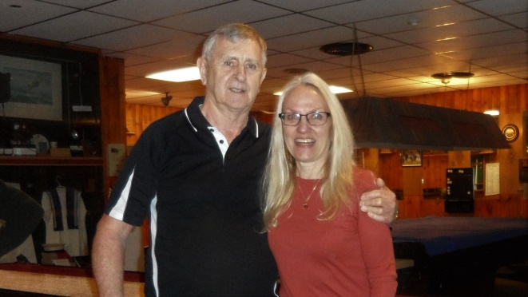

1st place winners from Lakefield-
Darlene and Jack Little

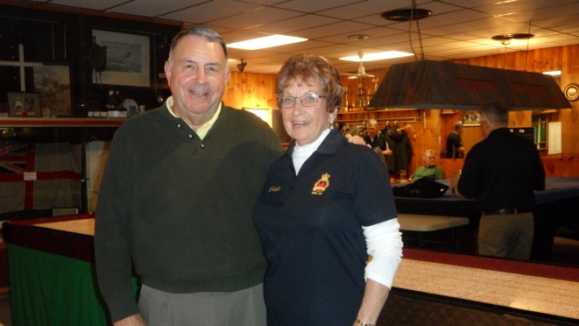
2nd place from Branch 99
Vivian White and Rick Law
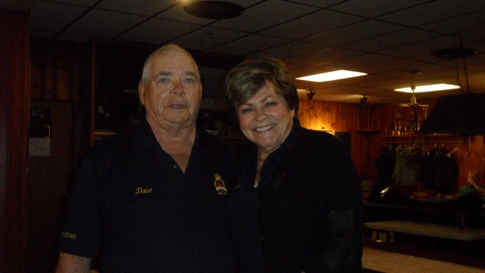
3rd place from Branch 99
Sylvia Butler and Dave Findlay

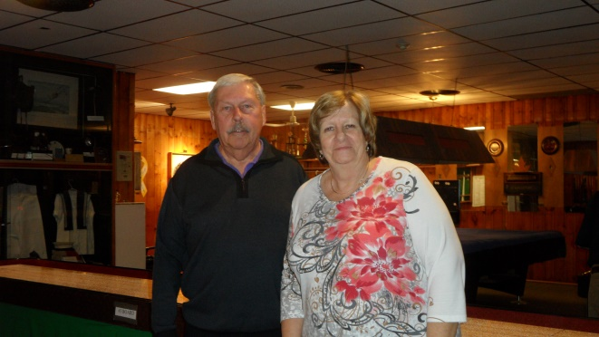
4th place from Lakefield
Jean Post and Dennis Gibson

Youth Education
Allan Miller

Our Youth Education Officer Allan Miller says the annual completion was a success.

Youth from the Belleville schools submitted 241 items through primary to intermediate school levels in poems, essays, black and white posters and coloured posters on the theme of Remembrance.

Ten first prize winners move on to Zone competitions. Perhaps out of these submissions Belleville will be honoured with a youth attending the 2018 Remembrance Ceremonies November 11, 2018 in the company of the Governor-General of Canada.

1st Place winners were

Essay
Junior -Benjamin Weinstein
Intermediate – Maria Baes

Poem
Junior –Carson Finnie
Intermediate – Vera-Lynn Eimers

Poster - Black and White
Primary – Harlee Irvine
Junior – Ava Bates
Intermediate – Cordela Crowley

Poster- Colour
Primary – Abeeha Moher
Junior – Olivia Mundle
Intermediate – Marni Bouwma

Thank you all who participated. There will be information posted in the New Year regarding the 2018 Legion Speech Contest.

Kitchen:

Monday – Wednesday 11:30 till 2:30
Thursday – closed
Friday – 11:30 till 7

Specials available daily

Ways and Means and Special Events
Pat Boulter

Remembrance Day
The Legion prepared and served about 300 people including 100 cadets a luncheon after the parade and services at the Cenotaph.
There are a number of people that I need to thanks including some students from Loyalist College, who came in to the Branch early last week and volunteered to help.

I want to say THANK YOU! To all those listed (on a separate page) you made my job much easier and our Remembrance Day Luncheon a great Success.

The sale of our Scratch Tickets earned s $140.00, which is divided equally with entertainment.

Our newest draw is for 2 dinners at the Legion and 2 Senators hockey tickets for Dec. 22nd game. It will be drawn on Dec. 3rd at the Christmas with Elvis show.

We are also going to have some Christmas Baskets ready for the end of the month. Tickets will be 3 for $5.00 draw will be made on the 22nd of Dec. approx. 6p.m

Starting Dec. 8th we will be having 5 meat draws on Friday evenings. Hams and Turkeys in time for the festive season.
The Twelve Days of Christmas
Written and Submitted by
Doris Fraser.

There is one Christmas carol that has always baffled me What in the World do leaping Lords, French hens, swimming Swans, and especially the partridge who won’t come out of a pear tree, have to do with Christmas.

TODAY I FOUND OUT!

From the year 1558 until the year 1829 Roman Catholics in England were not permitted to practice their faith openly. Someone during that era wrote this carol as a catechism song for young Catholics.

It has two level of meaning: The surface meaning, plus a hidden meaning, known only to the members of their church. Each element in the carol has a code word for religious reality a code word for religions reality which the children could remember.
The partridge in a pear tree was Jesus Christ.​
Two turtle doves were the Old and New Testaments​
Three French hens stood for faith, hope and love.​
The four calling birds were the four gospels of Matthew, Mark, Luke & John.​
The five golden rings recalled the Torah or Law, the first five books of the Old Testament.​
The six geese a-laying stood for the six days of creation.​
Seven swans a-swimming represented the sevenfold gifts of the Holy Spirit - Prophesy, Serving, Teaching, Exhortation, Contribution, Leadership, and Mercy.​
The eight maids a-milking were the eight beatitudes.​
Nine ladies dancing were the nine fruits of the Holy Spirit-Love, Joy, Peace, Patience, Kindness, Goodness, Faithfulness, Gentleness, and Self Control.​
The ten lords a-leaping were the Ten Commandments.​
The eleven pipers piping stood for the eleven faithful disciples.​
The twelve drummers drumming symbolized the twelve points of belief in the Apostles' Creed.
So this ends your history to-day.
This knowledge was shared with me and I found it very interesting so I thought I should share it with you.
The Legion Donates this month:
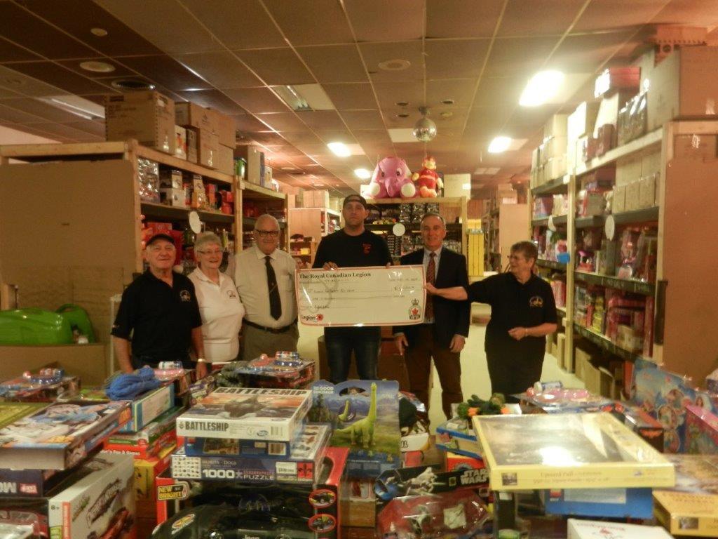
Fireman’s Toy Drive – $1,000.00
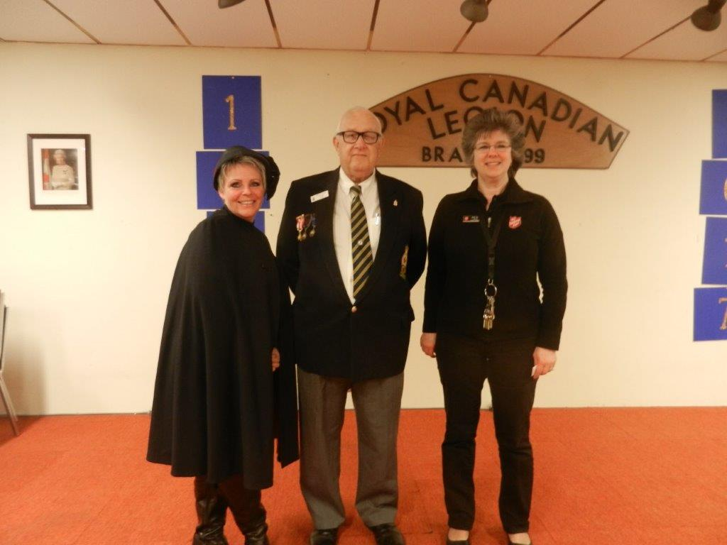
Salvation Army Kettle Drive - $2,000.00
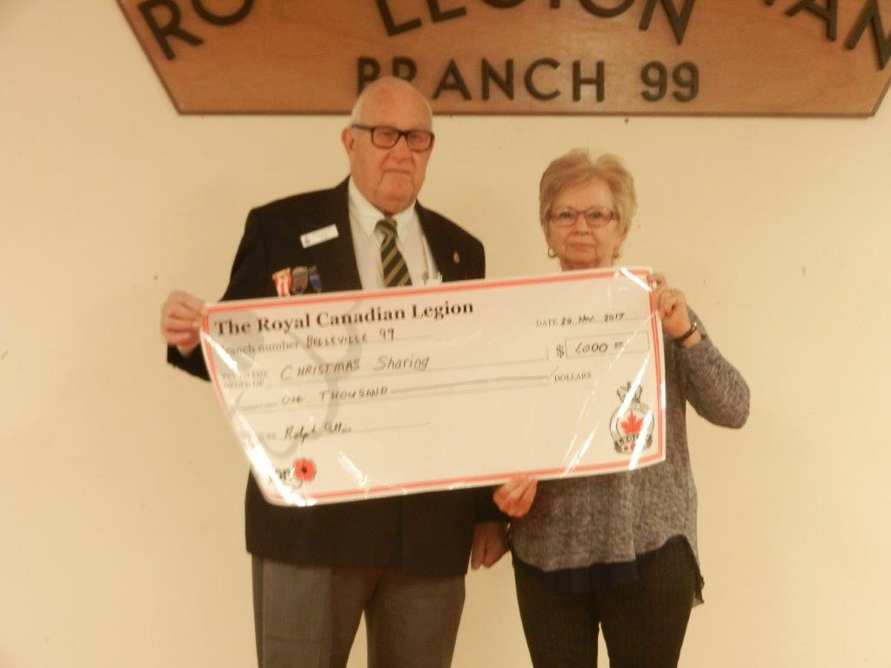
Christmas Sharing - $1,000.00
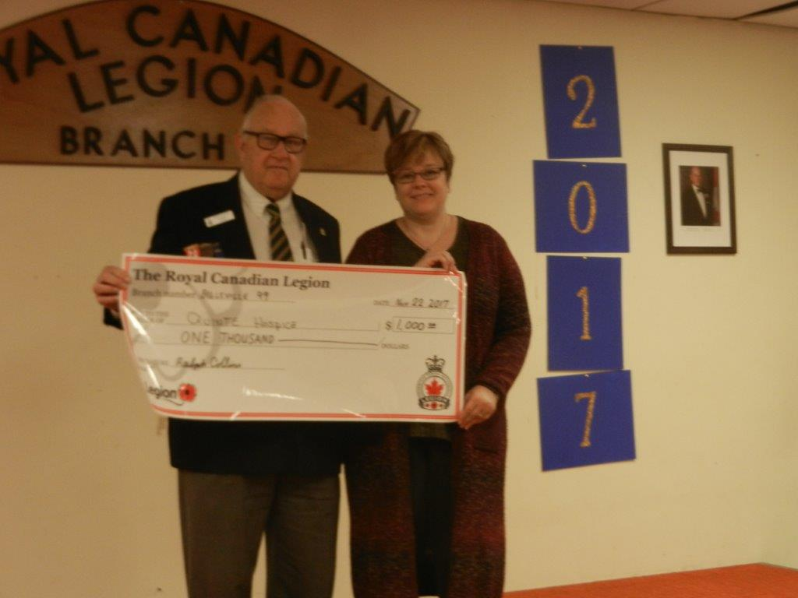
Quinte Hospic - $1,000.00
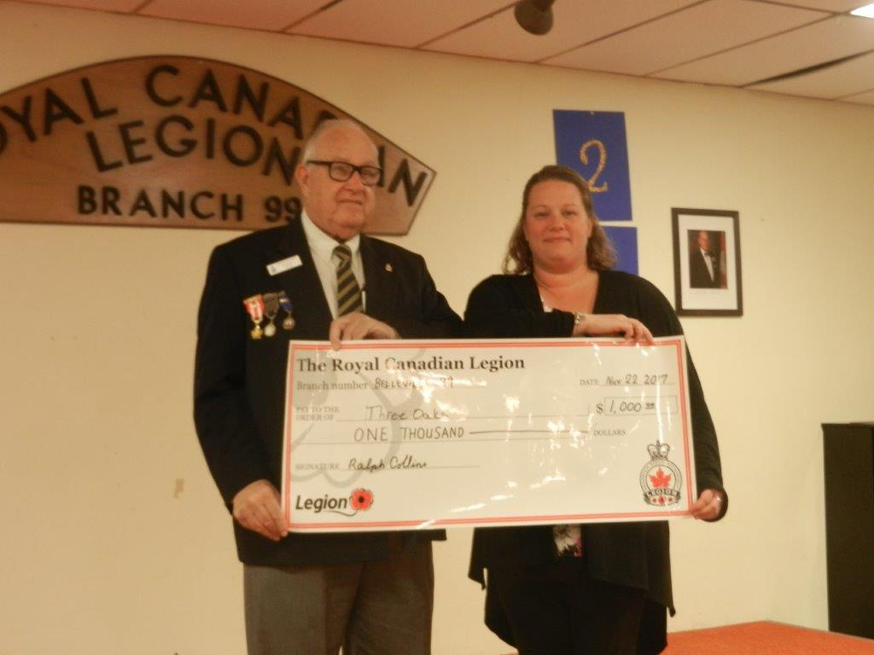
Three Oaks - $1,000.00
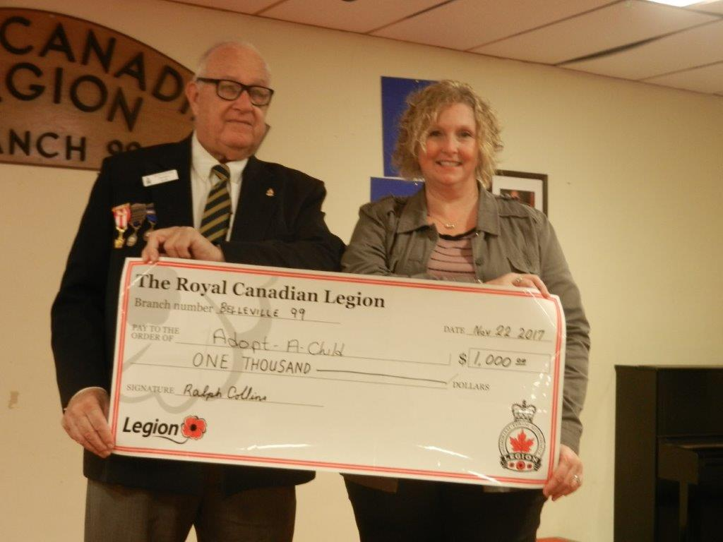

Adopt-A-Child - $1,000.00

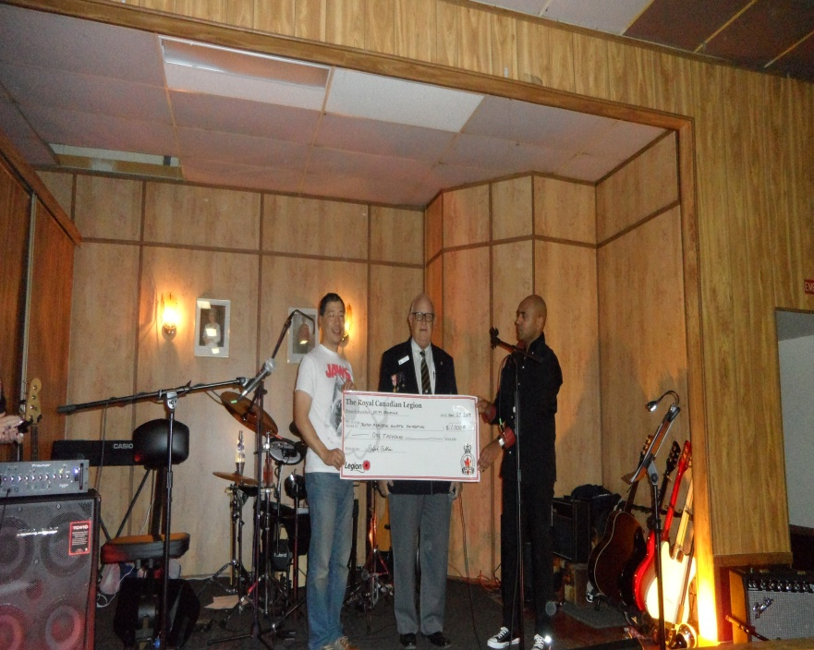
Trenton Memorial Hospital Foundation - $1,000.00
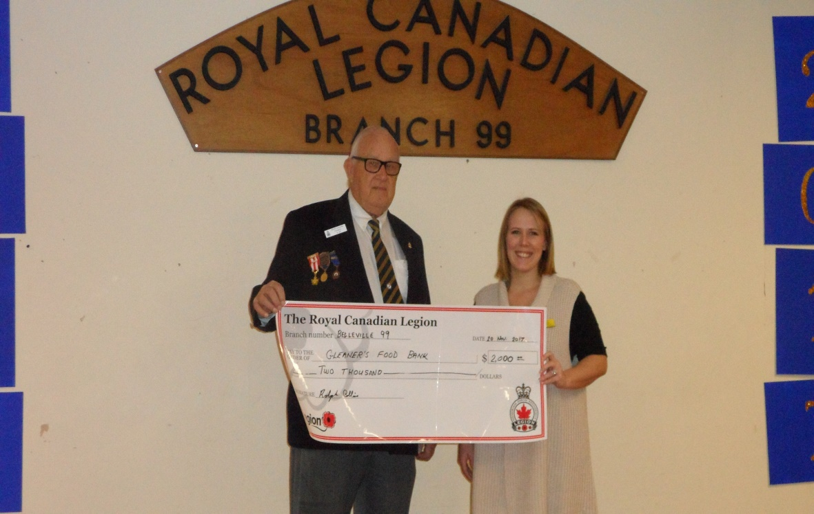
Gleaners Food Bank -$2,000.00

WOW what a busy month we have giving away so much money.

On behalf of the Executive and Staff we would like to wish everyone a safe and happy holiday Season.
Legion Office – 613 962-2643, Fax 613 968-9971, Bar 613 968-9053
www.mylegion.ca/web/
E-mail: info@mylegion.ca/web/
132 Pinnacle Street, Belleville Ontario, K8N 3A4

Membership Office Phone - 613-779-1434

President Ralph Collin 613- 962-8754
Past President Andy Anderson 613- 968-7261
1st Vice President Joyce Nickerson 613-966-7179
2nd Vice President Jack Crozier 613 962-2101 613 920-2101
3rd Vice President Mike Joyce 613 967-5923
Secretary Heather Fehr
Treasurer Joe Drummond 613- 962-7947
Padre/Funerals Ralph Collins 613- 962-8754
Sgt-At-Arms Don MacPherson 613- 779-0773 613 847-1415
Membership Mary Presley 613- 967-6494
Honours & Awards Robert Kooman 613-969-7706
Service Officer Doreen Guimont 613 966-4297
Poppy Joyce Nickerson 613-966-7179
Sports/Track & Field Dave Findlay 613-968-4080
Youth Education Allan Miller 613- 968-9655
Bingo Frank Freeman 613- 394-3851
Bar Jack Crozier 613- 962-2101
House/Property Mike Joyce 613 -967-5923
Entertainment Ralph Collins 613- 962-8754
Special Events/Ways & Means Pat Boulter
Enlightener Shirley Stewart 613-967-9723
Training & Development Mike Joyce 613 967-5923
Kitchen Joyce Nickerson 613-966-7179
Sick & Visiting Janis Drummond 613 962-7947

Volunteers Wanted!
Volunteers are being sought to assist RCL Branch 99 with our various programs including the Charity Bingo, Canteen, Public Relations, Youth Education, Entertainment, Sports, and Colour Party etc. Please contact the Committee Chair listed above in the area that you are interested in. Without your support RCL Branch 99 cannot continue promoting Remembrance, supporting Veterans and the various local charities. Please get involved!

